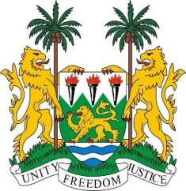
SIERRA LEONE
22nd Session of the UPR

MONGOLIA

5 May 2015

Mr President,

Sierra Leone welcomes the delegation of Mongolia and thanks them for the comprehensive update of their national report.

My delegation commends the Government of Mongolia for its moratorium on the death penalty and its ratification of the second optional protocol of the ICCPR, ICPPED and OPCAT. Sierra Leone also applauds Mongolia on the steps taken to provide equal access to education, for example, through the Law on Education and the open education program (One Mongolia, 2014), as well as the for the passing of the Gender Equality Act.

Nevertheless, Sierra Leone would like to encourage Mongolia to adopt a working definition of torture which is in line with international standards. urges Mongolia to comply with international legislation as regards child labour.

Sierra Leone would like to make the following recommendations:

- Ratify the ICRMW and the Conventions on Refugees and Stateless persons.
- Revise the law governing the National Human Rights Commission and develop its capacity to bring it in line with the Paris Principles
- Criminalize all forms of human trafficking of children by strictly enacting the anti-trafficking legislation.
- Establish a comprehensive framework on juvenile justice which is in conformity with international standards.

To conclude, Sierra Leone wishes Mongolia a successful completion to this second cycle.

Thank you, Mr President.

